

**Name : PRATHAMESH KALAPPA PADGANUR**

**Roll no : 18**

**Subject: Prompt Engineering**

**SRN: 3121499**

First input :- 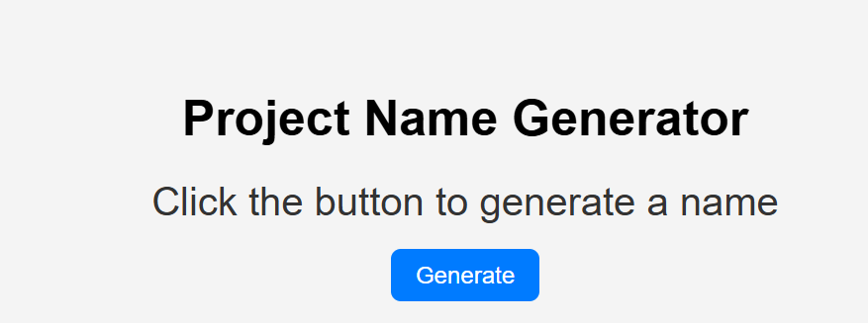

2nd input:- 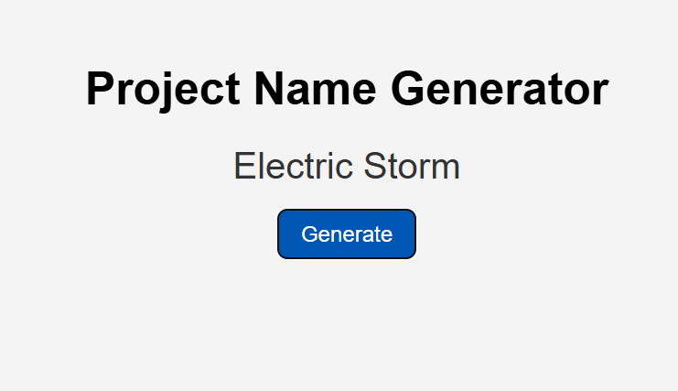

3rd input:- 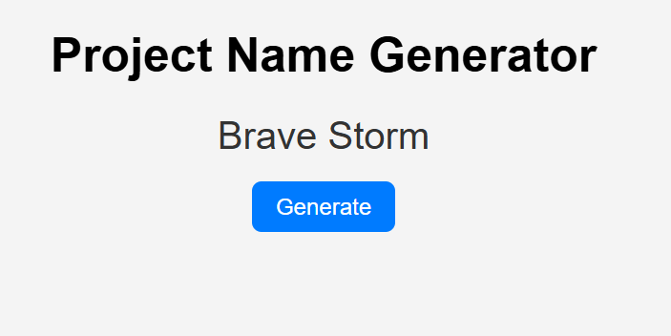

**CODE USED :-**

<!DOCTYPE html>

<html lang="en">

<head>

<meta charset="UTF-8" />

<meta name="viewport" content="width=device-width, initial-scale=1.0"/>

<title>Project Name Generator</title>

<style>

body {

font-family: Arial, sans-serif;

background: #f4f4f4;

text-align: center;

padding-top: 100px;

}

h1 {

font-size: 2.5rem;

}

#name {

font-size: 2rem;

margin: 20px;

color: #333;

}

button {

padding: 10px 20px;

font-size: 1.2rem;

background: #007bff;

color: white;

border: none;

border-radius: 8px;

cursor: pointer;

}

button:hover {

background: #0056b3;

}

</style>

</head>

<body>

<h1>Project Name Generator</h1>

<div id="name">Click the button to generate a name</div>

<button onclick="generateName()">Generate</button>

<script>

const adjectives = ["Epic", "Silent", "Smart", "Brave", "Quantum", "Electric", "Mystic", "Dynamic", "Rapid", "Infinite"];

const nouns = ["Falcon", "Nova", "Core", "Storm", "Matrix", "Pulse", "Vortex", "Spark", "Vision", "Beacon"];

function generateName() {

const adj = adjectives[Math.floor(Math.random() * adjectives.length)];

const noun = nouns[Math.floor(Math.random() * nouns.length)];

document.getElementById("name").innerText = `${adj} ${noun}`;

}

</script>

</body>

</html>

**PROMPTS USED:-**

1} give me a code to make a project name generater integrating api features.

2} make it dynamic where it can generate based on the custom additional details

3} optimize for server

Report by

Prathamesh padganur,

Thank you ,